**Real Estate Portfolio Analysis**

Hector Enriquez

**Introduction**

For this project, I set out to solve a real-world scenario in real estate using goal programming techniques to determine the most optimal investment strategy. My goal was to simulate the decision-making process for a lottery-winning client interested in purchasing 5 to 10 homes in a high-value area while minimizing risk and maximizing profit.

To do this, I gathered real estate data from Zillow and BrightMLS, focusing on the McLean, Virginia (22101) area region known for top-tier schools and amenities. I focused on single and double-family homes with comparable square footage to ensure uniformity in analysis. From an original dataset of 360 listings, I narrowed it down to a sample of 100 homes for detailed analysis.

Using Microsoft Excel, I calculated key financial indicators such as ROI (Return on Investment), standard deviation, and expected profit, which laid the foundation for identifying optimal investment strategies under different risk scenarios.

**Scenario**

A high-net-worth client has won the lottery and is working with Zillow to purchase **between 5 to 10 homes** in the McLean, VA area. Their total investment budget is **$20,000,000**, and they are looking for **multiple optimized portfolios** that consider both **low-risk and high-reward opportunities**.

Using price history, current market value, predicted future value, and expense data, I developed models to provide **low-, medium-, and high-risk investment portfolios**, helping the client choose the most effective strategy based on their comfort with risk.

**Scenario Goals**

**• Identify the current market price for 100 selected homes**

**• Compile and analyze 5-year historical price data**

**• Calculate ROI and price deviations**

**• Provide a Low-Risk optimal portfolio**

**• Provide a Medium-Risk optimal portfolio**

**• Provide a High-Risk optimal portfolio**

**Analysis**

The first step to providing an optimal solution starts with obtaining the essential raw data that will be needed to calculate the solutions. In this case, the current market price and the historical market price of each house are needed so that the ROI for each year and the ROI for the current market price can be calculated. The ROI is used to calculate the Standard deviation based on history and the standard deviation of the current market price. If I look at the data provided in columns C-H I can see that there is market saturation.

After gathering the data from our source. I have given each house a code, so in the end, I know which houses to purchase for the special customer. The houses I re inserted into Excel at random and given codes from 1-100 as they I re inserted into Excel. I have also created individual columns for the House code, the house address, and their current market value. After creating these 3 columns I have imported the past 5 years of their market value to the next 5 columns to feature how the prices have changed if at all and how the market is saturated.

To calculate the ROI of the historical data I need to take the data from each year and use the formula, according to our Excel sheet, (E2-D2)/D2. In this case, E2 is the price from year 2 and D2 is the price from year 1. So basically, we are implementing the formula NET INCOME/ COST OF INVESTMENT. We have to repeat this process for each year and for every house and one of the houses that we have on Excel. To find the current market price ROI I need to do, from our Excel sheet, (C2-H2)/H2 where C2 is the current market value of the house and H2 is the last year’s market price for the house.

After calculating the historical and current ROI of the houses I can calculate the standard deviation to filter out the saturation on the market. First to find the historical deviation variable I need to use the formula, from our Excel sheet, STDEV.S(J2:N2). In this case, J2 is the ROI for year 1 and N2 is the ROI for year 5. With the given formula excel can calculate the standard deviation of the variables from the historical 5-year data. To calculate the Standard deviation of the current market value I need to use the formula, from our Excel sheet, STDEV.S(J2:O2). In this case, J2 is the ROI from year 1 and O2 is the ROI of the current market price. Instead of stopping at year 5, I can include the current market price ROI to find the standard deviation for the current market price.

After finding the standard deviations from our data we need to find the Expected Profit that the client can get from our data sets. For this step, I just need to make the formula, from our Excel sheet, N2*H2. Where in this case N2 stands for the ROI of year 5 and H2 stands for the historical price from the 5th year. After analyzing the data found from the Expected Profit, I can still see the fluctuation and the market saturation. So, we then would need to find the Historical and Future Risk Adjustment Profit.

To calculate the Historical and Future Risk Adjustment Profit I need to define what will be the risk and the values for it. Since the market is fluctuating and in the real estate market everything can change daily, I decided to give the risk factors a range between 0 and 1. Whereas if II put0 the portfolio will be more risk prone. If I place it as 0.5 it will be medium risk and if I place 1 it will be risk averse. To calculate the Historical Risk adjustment I used the formula, from our Excel sheet, N2*D2 - Z$4*P2. Where N2 is the ROI from year 5 since I am calculating the historical value. D2 is the house value from year 1. Z$4 is the risk factor that the user can input. P2 is the standard deviation from the historical data. I am finding our total profit and subtracting the product from the risk factor and the deviation.

To calculate the Future risk Profit after choosing the risk penalty I want to use, I can use the formula O2*C2 - Z$4*Q2 from our Excel sheet. Where O2 stands for the ROI from the current market price. C2 stands for the current market price of the home. Z$4 again stands for the risk factor. Q2 stands for the standard deviation from the current market price of the home. By doing these calculations I can have a better idea of how the house price could change depending on which data I decide to go with.

In our case I wanted to give the best possible recommendation so I decided to combine both prices I was able to find and get the mean of the Historical and Future Risk adjusted Prices. So, for that, I used S2+T2/2. Where S2 stands for the Historical Risk-adjusted price and T2 stands for the Future Risk Adjusted Price. So, by getting the meaning from these prices, we can predict the price of the house that can be sold in the future.

After getting our final Combined Risk Adjusted Profits, we can use our constraints and Excel solver to figure out which houses I need to acquire for the client that will meet their specific needs. So, we need to make sure to follow the rules and choose our variable decisions and compute the optimal solutions for this project.

**Identification of Decision Variables**

There are only two types of decision variables in our analysis. The first one is the risk penalty range between 0 and 1. Where the user can decide if they want to be risk-prone or risk aversive while selecting the assets

Our second decision variable is simply which houses are going to be purchased with the given budget.

**Constraints**

After laying all the data to Excel and looking at the customers’ requests, I have 5 constraints for this optimization. Our first constraint is to set column V, the buy column, to binary. This will set the values to either 0 or 1. Because someone can't buy half of a house.

Our second constraint is the budget that the customer must buy the 5-10 homes. We can set this up by using the SUMPRODUCT function of the 2 rows that have the current market price and if it has a 1 on their Buy column. So, if we do the function SUMPRODUCT(C2:C102, V2; V102) I can get the total amount of money that the customer has to spend to buy 5-10 houses.

Our third constraint will be the number of homes that can be bought with the current budget that the client offers. For this, we have used the SUMPRODUCT function and taken the total of column V, the BUY column, and then we set in the solver that the product I get is equal to or less than 10 and equal to or greater than 5. This will make the solver look for at least 5 houses to select from and a maximum of 10 houses.

Our fourth constraint and our goal were to maximize the total amount of money that the customer would make/profit after selling these homes. For this constraint, I have looked over the current deviation and the past deviation with the Future and Historical Risk Adjustment Prices to predict a price that can be used for the selected houses. This number that Excel Solver finds should be more than the amount that the customer uses from their funds.

Our fifth and last constraint is the risk penalty. There are a lot of factors that go into deciding the final price of the houses. So, we have implemented a risk penalty that can be manually changed from 0 to 1 whereas the number goes higher, the model becomes more risk-averse meaning that it will take few risks and focus more on the stable priced homes.

In the below figure, we can see all the constraints that I mentioned in the paper.

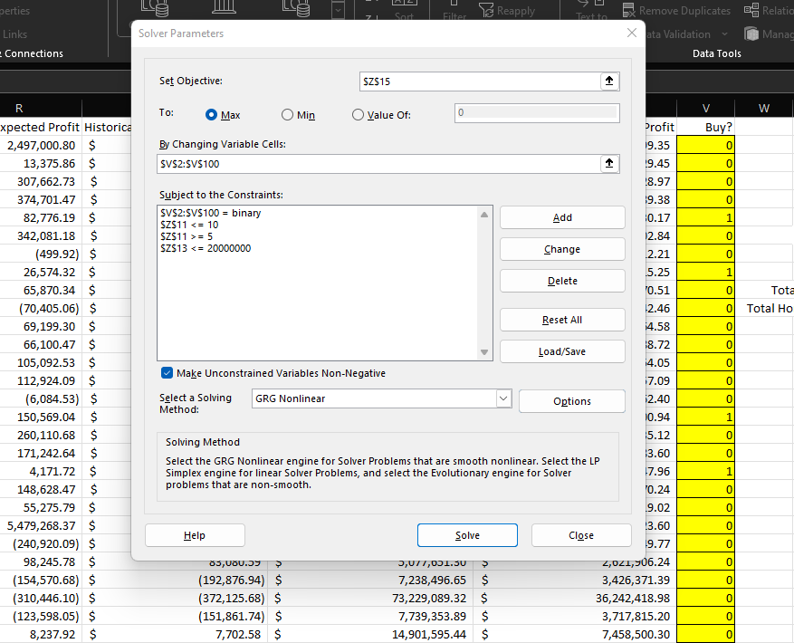

**Solution**

The following graphs show the risk levels low, medium, and high. The first graph I will go over is the low-risk decision model.

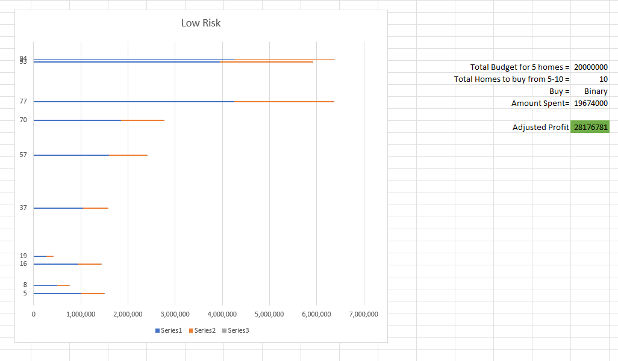

As I can see, the low-risk model bought the houses coded 5,8,16,19,37,57,70,77,93,94. So it bought the full 10 houses the client spending under 20M$ and made a profit of 28.2M$ for the client.

The graph below shows the results from the medium-risk decision model.

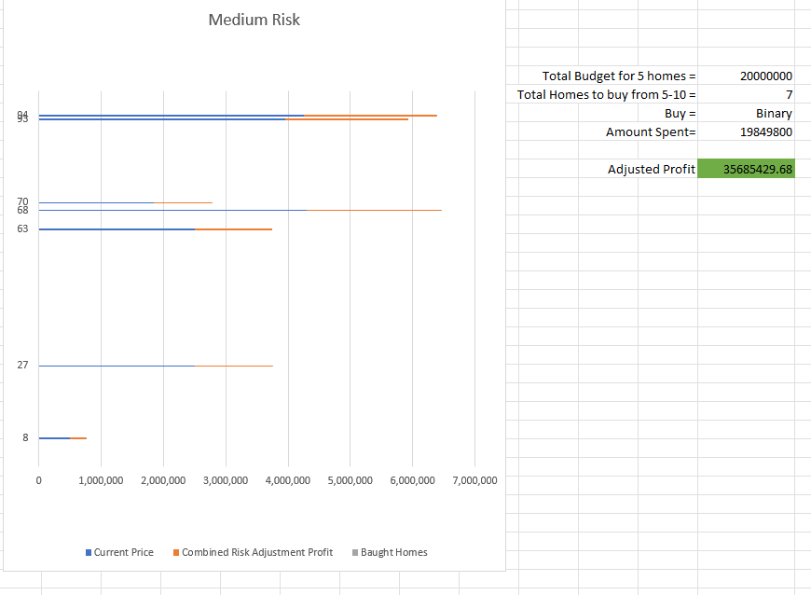

As we can see from the graph above, the medium-risk model only bought 7 houses. It still fits in with the client's requests. It spent less than 20M$ and made the biggest profit of 35M$.

T

The graph below shows the results from the high-risk decision model.

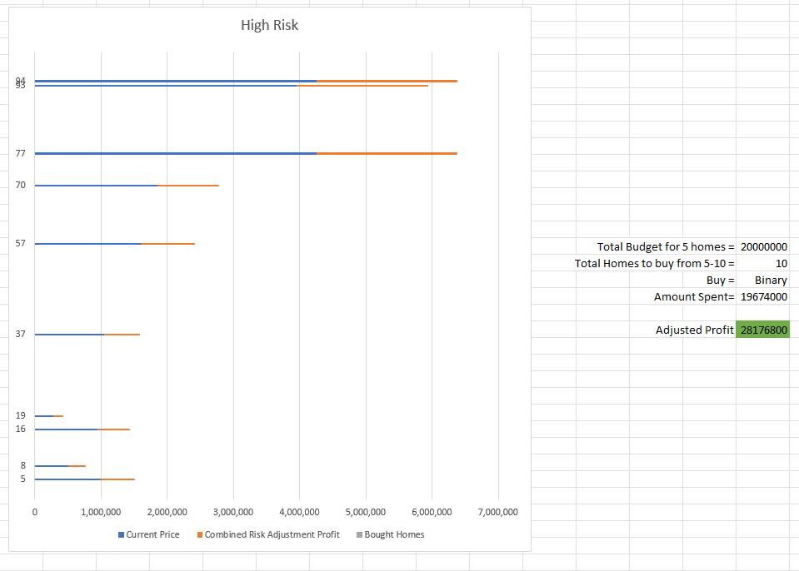

As we can see from the graph above, the high-risk model spent 19.7M$ and got a similar profit with the low-risk model of 28.2M$.

**Conclusion and Recommendations**

After gathering all the information, I recommend the customer pick the medium-risk portfolio because it shows the lowest amount of money spent buying houses with the highest amount of return on the investment. In addition to saving more of the budget provided, depending on the requested houses, the medium-risk portfolio provides an adequate amount of houses for the investment that is required. On the other hand, If the customer decides that they want more homes than our recommended solution then, the optimal decision I recommend is the low-risk portfolio because that solution provides more houses for less money than the higher-risk portfolio for nearly the same return of investment.

**References**

Gillis, A. S. (2021, August 18). *What is ROI? How to calculate return on investment*? CIO. <https://www.techtarget.com/searchcio/definition/ROI#:~:text=The%20most%20common%20is%20net,Cost%20of%20investment%20x%20100>.

Khan Academy. (n.d.). *Standard deviation: Calculating step by step (article)*. Khan Academy. https://www.khanacademy.org/math/statistics-probability/summarizing-quantitative-data/variance-standard-deviation-population/a/calculating-standard-deviation-step-by-step

*Listing search form - search for real estate properties: Homes for sale and Rent*. Listing Search Form - Search for Real Estate Properties | Homes for Sale and Rent. (n.d.). <https://www.brightmlshomes.com/Listing/ListingSearch.aspx>

Zillow, Inc. (n.d.). *22101 real estate - 22101 homes for sale*. Zillow. https://www.zillow.com/mclean-va-22101/?searchQueryState=%7B%22usersSearchTerm%22%3A%22555+10th+Ave+%2335G+New+York%2C+NY+10018%22%2C%22mapBounds%22%3A%7B%22north%22%3A38.99108863132462%2C%22east%22%3A-77.06074209448242%2C%22south%22%3A38.880795664137544%2C%22I st%22%3A-77.26158590551758%7D%2C%22isMapVisible%22%3Atrue%2C%22filterState%22%3A%7B%22sort%22%3A%7B%22value%22%3A%22days%22%7D%2C%22ah%22%3A%7B%22value%22%3Atrue%7D%7D%2C%22isListVisible%22%3Atrue%2C%22mapZoom%22%3A13%2C%22regionSelection%22%3A%5B%7B%22regionId%22%3A67147%2C%22regionType%22%3A7%7D%5D%2C%22pagination%22%3A%7B%7D%7D